**Reply to editors**

We thank the editorial board for the opportunity to revise our manuscript. Our responses to the reviewers’ comments are outlined below in regular font with editor/reviewer’s comments in bold font.

**Your manuscript "Potential gains in life expectancy by reducing inequality of lifespans in Denmark: An international comparison and cause of death analysis" (PUBH-D-18-01180) has been assessed by our reviewers. Based on these reports, and my own assessment as Editor, I am pleased to inform you that it is potentially acceptable for publication in BMC Public Health, once you have carried out some essential revisions suggested by our reviewers.**

Thank you again for considering our manuscript.

José Manuel Aburto

Maarten Wensink

Alyson van Raalte

Rune Lindahl-Jacobsen

**Reply to reviewers**

We appreciate the reviewers' comments; their detailed reading of the manuscript and suggestions that have greatly improved the article. Our responses to the reviewers’ comments are outlined below in regular font with reviewer’s comments in bold font.

**Reviewer: 1**

**Henrik Bronnum-Hansen (Reviewer 1): This study gives more insight into the cause of the long lasting and disturbing mortality trends in Denmark. The authors simultaneously investigate trends in life expectancy, lifespan inequality and decomposition by cause of death.**

**The manuscript is well written and my comments, questions and suggestion are few:**

**1. Although life expectancy is well known, lifespan may be less. So as a service for readers not in well-informed circles I recommend to introduce the definition(s) or the overall concept(s) of (life expectancy and) lifespan in the introduction of the paper before describing the characteristics of the two health indicators.**

**2. The first sentence on page 3 should start "Life expectancy is one of the most commonly used measure…", because health expectancy and other summary measures of population health become increasingly more widespread.**

**3. I suggest that you add a little more explanation to the sentence (page5-6): "We also checked for discontinuities in death counts…"? In Figure 2-4 "ICD7" is missing in the description of categories. I am not sure that I understand how to interpret the graphs.**

**4. Please, add extra information in the title of Figure 2 (similar to that of Supplementary Figure 1).**

**5. In the Supplemental material "2) Brief description of the indicator" this is named CV. Change that to CoV as this is used in the text. Also chance "e0" to "ea" in the explanatory text to the formula (1).**

**Reviewer: 2**

**Sasson Isaac (Reviewer 2): This is an interesting descriptive paper looking at changes in life expectancy and lifespan inequality in Denmark from 1960 to 2014. The authors hypothesize that (1) Denmark will exhibit greater lifespan inequality relative to its neighboring countries; and (2) Life expectancy and lifespan inequality (variability) will stagnate between 1975 and 1995, primarily among women, due to higher smoking prevalence in the 1919-1939 birth cohorts.**

**Using HMD mortality data and WHO cause-of-death data, the authors find support for both hypotheses and point to possible health interventions with respect to infant mortality and cancers, which were responsible for the bulk of those patterns/trends (i.e., life expectancy and lifespan inequality improvements over time and relative to similar countries).**

**Overall, the paper is well written and the methods are appropriate. To their credit, the authors were mindful of possible limitations (e.g., ICD classification discontinuities, reliability of cause-of-death classification in old age) and addressed them in a satisfactory manner, either in the main analyses or in supplementary sensitivity analyses.**

**A few remaining suggestions:**

**1. The comparison with Sweden received substantial exposition (p. 3 second paragraph), as well as subsequent analyses (cause-of-death decomposition in Fig. 3), but not Norway. For example, Fig. 2 shows that Norway experienced similar stagnation in life expectancy and (more so) in lifespan variation from 1975-1995. In other words, Norway was closer to Sweden in levels but more similar to Denmark in trends. However, this similarity is not explored or explained, so I recommend that the authors either bolster the Denmark-Norway comparison or drop this third country altogether.**

**2. The findings suggest that smoking-related cancers and non-infectious respiratory diseases had largely driven the stagnation in life expectancy from 1975-1995. Those same causes were responsible for positive contributions to lifespan inequality below age 70 (among women) and negative contributions in older ages—both of which attributed to rising smoking-related mortality across the board. In other words, the negative contributions from smoking were also undesirable, because they resulted from increasing mortality above the young-old threshold age, which the authors acknowledge in the discussion section (p. 11). I suggest introducing this concept earlier in the paper and plotting the threshold age in Fig 2, Panel B to make this point clearer.**

Thanks for the suggestion. We now introduce the concept of the threshold age since the Methods section:

The corresponding part of Figure 2 now has the threshold age with a dotted line, it looks like:

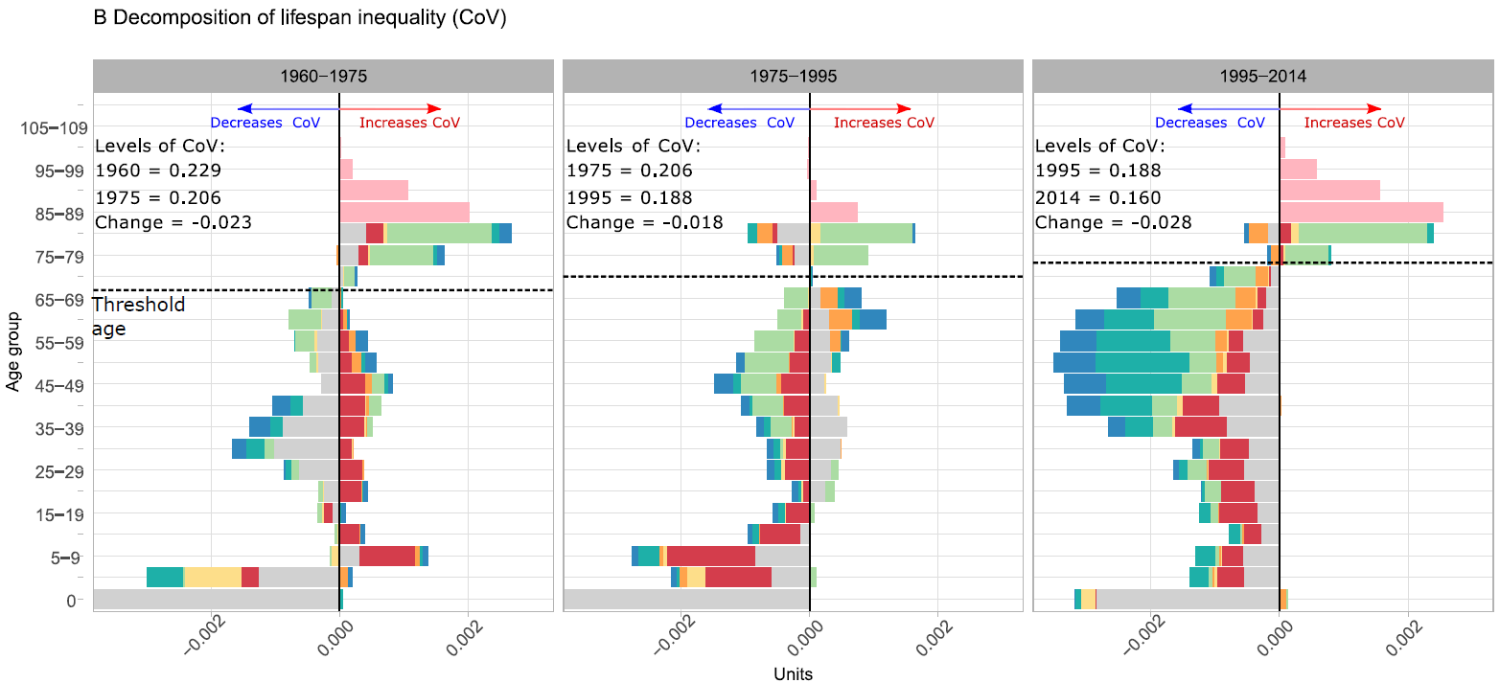

**3. The authors relied on CoV to measure lifespan inequality. However, because this measure is directly dependent on life expectancy, the interpretation of the findings (particularly comparison with other countries) is not always straightforward. For example, the CoV diverged between Denmark and Sweden in the 1980s, but we cannot tell whether the Swedish CoV declined because of absolute reductions in SD (numerator) or simply increases in life expectancy (denominator). Both effects would reduce the CoV, but each corresponds to a different mortality scenario (compression vs. translation). Therefore, I suggest applying alternative measures of lifespan inequality either in the main analyses or to be included in supporting materials.**

**4. It appears that non-smoking cancers also contributed to reductions in life expectancy and increases in lifespan inequality during the 1975-1995 period. Can the authors explore this further? Is this because their definition of smoking-related cancers was conservative, as explained in the Supplementary Materials, so some of the effect of smoking is captured in the remaining cancers? Or was there an overall cancer crisis (e.g., diagnosis, treatment) going on in Denmark? This is relevant to the interventions discussed at the end of the paper.**

**5. Phrasing: p. 11, first paragraph: "Therefore, the causes that extend lifespan and the causes that reduce inequality are not necessarily the same." I recommend changing "lifespan" to "average lifespan" or "life expectancy" so there is no confusion with "maximal lifespan."**

Thanks, we agree with this suggestion and have changed ‘Lifespan’ to average lifespan or life expectancy throughout the manuscript.

**----------------------**

**Editorial Policies**

**-----------------------**

**Please read the following information and revise your manuscript as necessary. If your manuscript does not adhere to our editorial requirements this will cause a delay whilst the issue is addressed. Failure to adhere to our policies may result in rejection of your manuscript.**

**In accordance with BioMed Central editorial policies and formatting guidelines, all submissions to BMC Public Health must have a Declarations section which includes the mandatory sub-sections listed below. Please refer to the journal's Submission Guidelines web page for information regarding the criteria for each sub-section (https://bmcpublichealth.biomedcentral.com/**

**).**

**Where a mandatory section is not relevant to your study design or article type, for example, if your manuscript does not contain any individual persons data, please write "Not applicable" in these sections.**

**For the 'Availability of data and materials' section, please provide information about where the data supporting your findings can be found. We encourage authors to deposit their datasets in publicly available repositories (where available and appropriate), or to be presented within the manuscript and/or additional supporting files. Please note that identifying/confidential patient data should not be shared. Authors who do not wish to share their data must state that data will not be shared, and provide reasons for this in the manuscript text. For further guidance on how to format this section, please refer to BioMed Central's editorial policies page - http://www.biomedcentral.com/submissions/editorial-policies#availability+of+data+and+materials.**

**Declarations**

**- Ethics approval and consent to participate**

**- Consent to publish**

**- Availability of data and materials**

**- Competing interests**

**- Funding**

**- Authors' Contributions**

**- Acknowledgements**

**- Authors' Information**